Set Up for BIMBY

Contents

Server Set Up 3

Host Name 3

Remote Desktop 3

WAMP Server 5

MYSQL and phpmyadmon 5

# Server Set Up

* Windows 10 Pro 64 bit
* Device Name: ‘sdvserver’
* Processor: Intel(R) Core(TM) i5-7600 CPU @ 3.50GHz 3.50 GHz
* Ram: 12GB
* Has MS Office 365 installed
* Has SnagIt installed

## Host Name

* Using [Duckdns](https://www.duckdns.org/) to translate changing IP address to fixed hostname as <http://bimby.duckdns.org>
* Registered under Stephen’s gmail account. [9sdeedesvincke@gmail.com](mailto:9sdeedesvincke@gmail.com))
* Must have a script running to trigger IP changes
  + <https://www.duckdns.org/install.jsp?tab=windows-gui&domain=bimby>
  + Needs java run time
* Ensure port 3389 for Remote Desktop and 3306 for MYSQL is open on the home router

## Remote Desktop

Remote Desktop is running as this is a Windows 10 “PRO” license

* Add a local account with admin access first

Then…

* To add users, go to Remote Desktop Settings
* Select User Accounts at the bottom of the screen

* add the user to the remote desktop
* Added Bimby user – which works

# WAMP Server

WAMP Server is installed on the sdvserver.

WampServer is a Windows web development environment. It allows you to create web applications with Apache2, PHP and a MySQL database. Alongside, PhpMyAdmin allows you to manage easily you

Open browser and type “localhost” to get started. Or double click “WAMPSERVER Homepage” icon on the desktop. There is a link to phpMyAdmin from the home pager or type localhost/phpmyadin/ to get started.

Plus to have it open to external access:

WAMPServer 3 has a different method

In version 3 and > of WAMP Server there is a Virtual Hosts pre defined for localhost so you have to make the access privilege amendments in the Virtual Host definition config file

* First don’t amend the httpd.conf file at all, leave it as you found it.

Using the menus, edit the httpd-vhosts.conf file.

[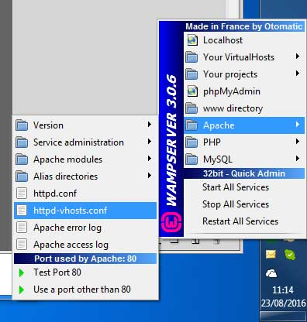](https://i.sstatic.net/mW5je.jpg)

It should look like this :

* <VirtualHost *:80>
* ServerName localhost
* DocumentRoot D:/wamp/www
* <Directory "D:/wamp/www/">
* Options +Indexes +FollowSymLinks +MultiViews
* AllowOverride All
* **Require local 🡨**
* </Directory>
* </VirtualHost>

Amend it to

* <VirtualHost *:80>
* ServerName localhost
* DocumentRoot D:/wamp/www
* <Directory "D:/wamp/www/">
* Options +Indexes +FollowSymLinks +MultiViews
* AllowOverride All
* **Require all granted <-**
* </Directory>
* </VirtualHost>

Hopefully you will have created a Virtual Host for your project and not be using the wamp\www folder for your site. In that case leave the localhost definition alone and make the change only to your Virtual Host.

## MYSQL and phpMyAdmin

* Test port 3306 using web Port checker [Port Checker - Check Open Ports Online](https://portchecker.co/)
  + If port 3306 is closed on Windows 10 Pro, it may be because a firewall is blocking it. To unblock port 3306, you can add a port exception to Windows Firewall Defender:
  + Open the Control Panel and click Security
  + Click Windows Firewall
  + Click Advanced Settings and then Inbound Rules
  + Click New Rule
  + Click Port and then Next
  + Select TCP
  + Click Next and then Allow the connection
  + Check Domain and Private
  + Enter MySQL as the name and description
  + Port 3306 is the default port for the classic MySQL protocol. It's used by the mysql client, MySQL Connectors, and utilities like mysqldump and mysqlpump.
* Will currently use MYSQL as default DB instead of MariaSDB.
* Users:
  + High level user is **root** and no password
  + User to access Database is
    - bimby/password see Melinda or Stephen